**EQI-based review for NFR**

The most common ones are performance, scalability, portability, compatibility, reliability, availability, maintainability, security, localization, and usability.

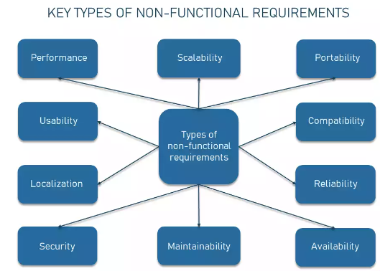

* **Performance and scalability**. How fast does the system return results? How much will this performance change with higher workloads?
* **Portability and compatibility**. Which hardware, operating systems, and browsers, along with their versions does the software run on? Does it conflict with other applications and processes within these environments?
* **Reliability, maintainability, availability**. How often does the system experience critical failures? How much time does it take to fix the issue when it arises? And how is user availability time compared to downtime?
* **Security**. How well are the system and its data protected against attacks?
* **Localization**. Is the system compatible with local specifics?
* **Usability**. How easy is it for a customer to use the system?

Usually, such sources as the above-mentioned BABOK list non-functional requirements in an isolated manner. We grouped some of them since the approaches to documenting these requirements overlap and some can’t be estimated without the other ones.